When I call from X-lite to Analog phone, the phone is ringing, and I pick up the phone, but X-Lite is continuing ringing, we don’t have a conversation
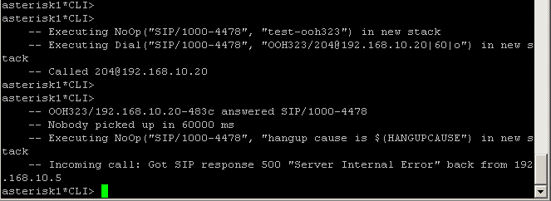

And when I call from Analog phone to X-Lite, the X-Lite phone is ringing, but when I accept the phone, the analog phone is continuing ringing. After that, the call is destroyed.
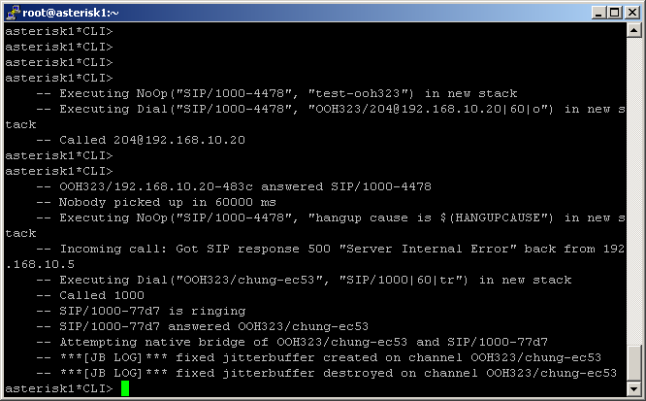

Ooh323.conf
[general]
bindaddr=0.0.0.0
port=1720
faststart=no
h245tunneling=no
h323id=ObjSysAsterisk
e164=100
callerid=asterisk
gatekeeper = DISABLE
logfile=/var/log/asterisk/h323_log
context=test-ooh323
rtptimeout=60
tos=none
accountcode=h3230101

; ONLY ulaw, gsm, g729 and g7231 supported as of now
disallow=all ;Note order of disallow/allow is important.
allow=ulaw
allow=alaw
allow=g729
allow=gsm

dtmfmode=TONE

[planet]
type=friend
context=test-ooh323
disallow=all
allow=ulaw
allow=alaw
allow=g729
allow=gsm
ip=192.168.10.20
port=1720
dtmfmode=TONE
rtptimeout=60

sip.conf
[general]

port = 5060 ; Port to bind to (SIP is 5060)
bindaddr = 0.0.0.0 ; Address to bind to (all addresses on machine)
disallow=all
allow=ulaw
allow=alaw
allow=g729
#include sip_nat.conf
#include sip_custom.conf
#include sip_additional.conf

[1000]
username=1000
userid=1000
secret=123456
type=friend
context=test-sip
host=dynamic
dtmfmode=rfc2833
canreinvite=no
qualify=yes
echocancel=yes
echowhenbriding=yes
disallow=all
allow=g729
allow=alaw
allow=ulaw

extension.conf

[test-ooh323]

exten => 1000,1,Dial(SIP/1000,60,tr)
exten => 1000,2,Answer( )
exten => 1000,103,HangUp( )

exten => 2000,1,Dial(SIP/2000,60,tr)
exten => 2000,2,Answer( )
exten => 2000,103,HangUp( )

[test-sip]

exten => 1000,1,Dial(SIP/1000,60,tr)
exten => 1000,2,Answer( )
exten => 1000,103,HangUp( )

exten => 2000,1,Dial(SIP/1000,60,tr)
exten => 2000,2,Answer( )
exten => 2000,103,HangUp( )

exten => 204,1,NoOp(test-ooh323)
exten => 204,n,Dial(OOH323/204@192.168.10.20,60,o)
exten => 204,nHangUp
exten => h,1,NoOp(hangup cause is $(HANGUPCAUSE)}

